

**e-Yantra Robotics Competition - 2018**

**Theme and Implementation Analysis – Hungry Bird**

**6768**

|  |  |
| --- | --- |
| **Team leader name** | Sumit Sourabh |
| **College** | IIT Patna |
| **Email** | sumitsourabhiitp@gmail.com |
| **Date** | 2/1/2018 |

**Scope and Preparing the Arena**

**Q1 a. State the scope of the theme assigned to you. (5)**

In this theme, we have to make the drone take off, go through the hoops as fast as possible and return back to the source tree. This theme will teach us control theory, simulation and path planning. All 3 concepts have very wide application in both mobile and non-mobile robotics. Hence, this theme is very relevant. First, we have to simulate the real world inside V-REP. Then we have to plan our path and send relevant control signals to the drone. ROS acts as a communication layer between all the software packages.

1. **Attach the Final Arena Images. (5)**

< Prepare the arena according to the steps given in the *Arena* section in Rulebook.

Place the Food Trees & Non-Food Trees in randomized positions and orientations as per the Rulebook and take 3 photos of the completed arena from different angles such that the entire arena is clearly visible in the photos.

The three image files should be uploaded along with this document.>

TODO: ask others for images

**Testing your knowledge (theme analysis and rulebook-related)**

**Q2. How will you ensure that while tuning the PID value, Drone will not crash? (5)**

To prevent the drone from crashing, we tried creating a harness to prevent the drone from going too far. Additionally, the harness will allow us to manually move the drone to any desired position with ease. We created the harness with string, but the problem is that the string would get tangled with the propellers during takeoff. That was solved by keeping the entire length of the string below the drone before takeoff. Later on, we discovered a simpler method to prevent a crash. We programmed the drone to disarm if it goes outside a bounding box. This method worked well and prevented the drone from suffering crashes.

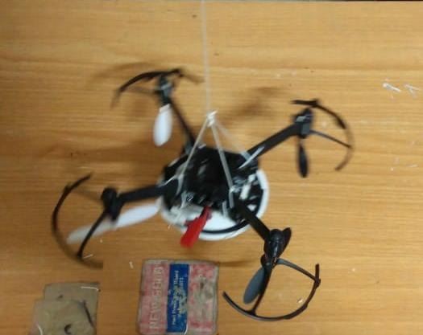  
String harness

**Q3. How will you navigate the drone through the hoops. Do you anticipate to loose input from the overhead camera while the drone is crossing the hoop? If yes, how are you planning to deal with this scenario? (5)**

First, we have to simulate the positions and orientations of the hoops inside V-REP using Whycon and Aruco markers. Then we have to use the OMPL path planning tool to plan a path from hoop to hoop. One problem in this strategy is that we must not aim at the centre of the hoop, we have to aim a little beyond the hoop so that the drone actually crosses it.

Yes, we anticipate to loose input from the overhead camera while the drone is crossing the hoop. To deal with this, we have to make sure that none of the waypoints in the path are in the region of no-input. There should be one waypoint before the region and one waypoint after the region. That way the PID algorithm will continue to push the drone towards that waypoint even if it looses input from the camera.

**Q4. What is the trend of WhyCon co-ordinates in a single real-world z-plane? (5)**

The problem is that in a single real-world z-plane, the Whycon z coordinates aren’t the same. This means that the transformation between real world coordinates and WhyCon coordinates is not linear. If we just use a simple linear transform between the two frames, then the positions of the hoops and even the drone will not be the same as that of the real world. This might cause a collision between the two. However, I think that this will not be a problem because the hoops are large and there is a lot of space between two hoops.

**Q5. What will be your strategy to earn maximum points in a run? (10)**

Obviously, the strategy to earn maximum points in a run is to take off, compute the fastest path through all the hoops, follow this path and then land back at the starting position without incurring any penalty and doing it under the time limit. The non-trivial thing among these is computing the fastest path. We can assume that the shortest path is the fastest path. Since the number of trees is small, we can try out all possible combinations. In addition to that, we can compute multiple paths using the OMPL plugin and choose the best out of them.

**Algorithm Analysis**

**Q6. Draw a flowchart illustrating the algorithm you propose to use for theme implementation. (10)**

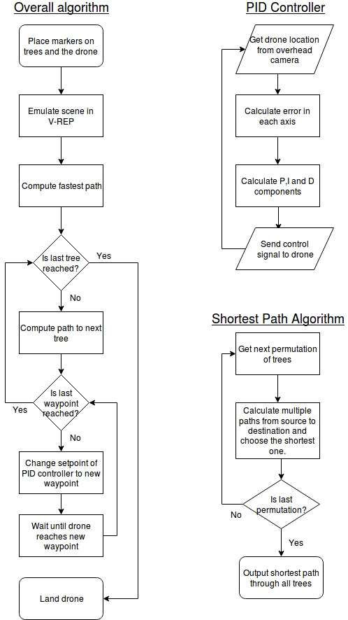

**Challenges**

**Q7. What are the major challenges that you can anticipate in addressing this theme and how do you propose to tackle them? (5)**

1. PID tuning

PID tuning on the real drone is a labourious and challenging task. Although there are some automated methods of tuning (like Ziegler Nichols method), I think manual tuning would be best for this problem.

2. Batteries

The batteries are really a hassle with regard to PID tuning. This is because as the battery voltage decreases, the drone’s performance decreases and the same PID parameters don’t work anymore. Also, the batteries provide a few low flight time of 5 minutes. So there is only around 10 minutes of window for testing before they again require recharging.

3. Drone crashing

If anything is not right, the drone will go out of control and crash. Although the drone is very durable, we must not crash it so much. So we have to put measures to either restrict the drone’s range or disarm it when outside the range.

4. Determining correct order of trees

Before the drone begins flying, it must decide the order in which to traverse the trees. This is a very important task because the wrong order can increase the flight time by a significant amount. Since the number of trees is small in this problem statement, we can afford to simulate every permutation and choose the best among them.

5. Computing the best path

The V-REP OMPL plugin does not give the absolute shortest path. Hence it is a better idea to compute multiple paths and choose the best amongst them.